Project Report

Project management

At our initial group meeting, we agreed to use the Agile framework to complete the project to give the team some degree of flexibility in the development process, given that the team was made up of six members from different modules and with schedules. We split the team into different roles that focused on different sections of the project overview following a meeting to identify each group members’ strengths and experiences, which helped achieve an effective task allocation. The team was made up of members from a design background, a software background and members with extensive knowledge in server and database configuration.

The task allocation stage was finalised following the initial meeting with the client, which helped accomplish a full breakdown of the project requirements, based on the knowledge gained from our initial task allocation meeting. A design team was formed to create a beautiful graphical use interface as stated in the project overview, and a development team was set up for the implementation of the project, with different tasks being allocated to individuals and small groups being formed within the team. The task breakdown technique functioned very well for the team because it has ensured that all members worked within their strengths and produced the best output of work for the client.

The tasks allocation and outcomes were as follows:

**Keri and Niamh**: Design - **Completed on marvel.com**

**Keri:** Design improvement on visual studio **- Completed**

**Louise:**Hiding the App - **Completed**

**Nicholas:** GPS location - **Completed**

**Niamh:** Database and server connection - **Not completed**

**Lewis:**Voice activation - **Completed**

**Serge:**  Implementation of the design on Visual studio, Sign up/Sign in, Alert button activation, Alert message forwarding via Email using SMTP, simulation of Alert SMS forwarding to contact, Phone number and Email validation for both the user and the contact, creation of static class to simulate a database to hold the input user's and contact's details - **All completed**

**Serge:** Live alert SMS forwarding system - **Not completed**

The following classes and interfaces were created on Visual Studio: Dialog_signUp.cs, Dialog_Contact.cs, Dialog_sign_In,cs, Alert.cs, MainActivity.axml, dialog_sign_up.axml, dialog_contact.axml, and dialog_Sign_In.axml.

The team used Facebook Messenger, GitHub and emails as primary communication tools. A group chat within Facebook Messenger was formed so that the team could send instant messages between members.

Additionally, the team had weekly meetings to discuss progresses made in the development of the project, to allocate the impending tasks for the week and to rectify any issues that may have occurred. We have found these meetings to be very beneficial because they provided an opportunity to brainstorm new ideas and methods to achieve our project goals.

The team had regular weekly meetings with the project supervisor to receive productive feedback and guidance in respect of the mobile application development progress, team contribution and overall project goals and processes. The consistency of these meetings proved to be difficult due to scheduling, with the project supervisors timetable and the team members’ different module timetables. We tried to solve this problem by ensuring as many group members as possible attended the meetings and created minutes which were then communicated back to the entire group.

The team used the GitHub repository and emails for file sharing. Through this, each member was able to share, edit and commit files easily, although the use of this repository could have been more effective had all team members been able to link their Visual Studio accounts to the repository to allow efficient code updating.

The Microsoft Excel team contribution worksheet has been kept up to date on a weekly basis as a means of assessing each team member’s contribution.

As far as deliverables and milestones are concerned, upon completion of the project, the team was on schedule with the design and implementation of a beautiful interface and the sign up and sign in, voice activation, alert button activation, email message forwarding to the contact, GPS location and hiding (working in the background) functions of the App.

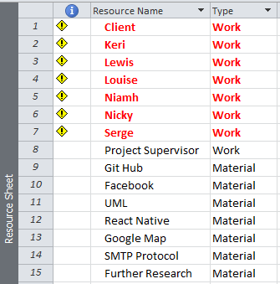

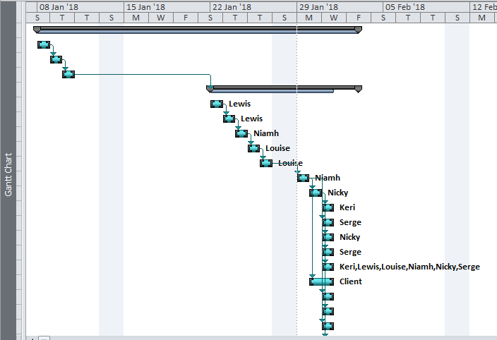 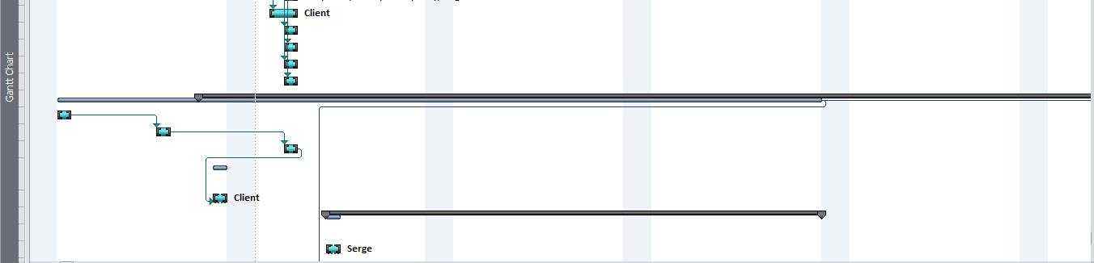 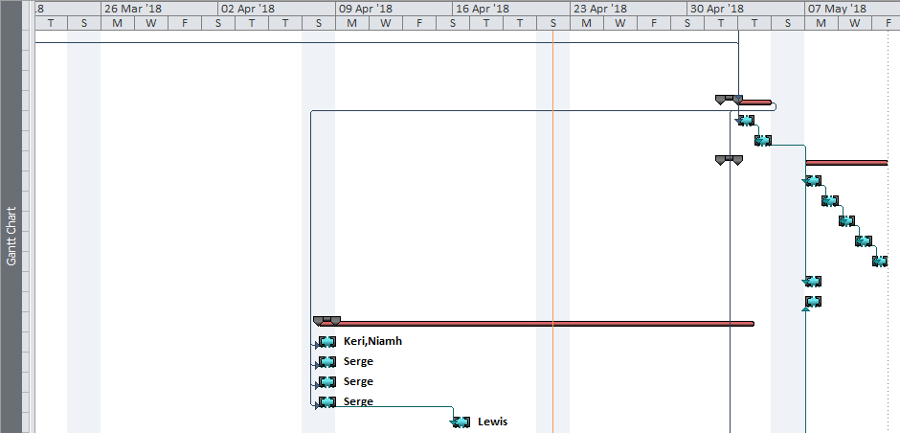 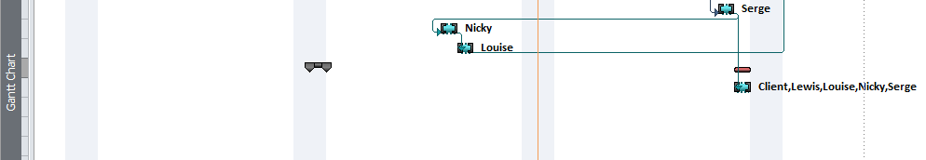

Conclusion

Upon completion of the project, the team has been able to meet most of the client’s specifications, except for being able to implement an alert SMS forwarding service for lack of appropriate software like APIs, although we managed to simulate it.

The team was able to present the project development and outcomes to an audience in a clear manner, although the project deliverables were not effectively presented at the demonstration stage.

The Application is fully usable and deployable despite shortcomings in being able to implement the alert SMS forwarding service and a database and server connectivity.

As far as team work was concerned, overall the team worked together smoothly without any major incident despite some quite understandable occasional disagreements, most on team contribution.

Collectively, the team learned to work together as part of a team quite well without letting personal feelings about each other get in the way, the complexity involved in working separately (remotely) on one single application development project and how important it is to set clear deliverables and milestones from the start of the project.

//Every team member should feel free to add to this conclusion as long as in the end the whole thing can be harmonised.

Appendix A

//Original PID (copy and paste)

Appendix B

Appendix C

//Detailed testing records (screenshots of the working App to be copied here)

Appendix D

Sign up page

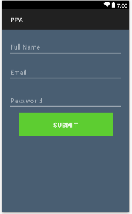

Contact page

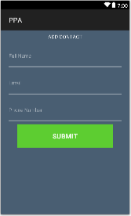

Sign in page

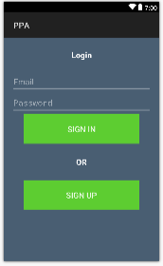

Main page (alert button page)

